

1

July 2023

Category review: Chips

Retail Analytics



Our 17 year history assures best practice in privacy, security and the ethical use of data

We all have a responsibility to use data for good

# Privacy

* We have built our business based on privacy by design principles for the past 17 years
* Quantium has strict protocols around the receipt and storage of personal information
* All information is de-identified using an irreversible tokenisation process with no ability to

re-identify individuals.

Security

* We are ISO27001 certified - internationally recognised for our ability to uphold best practice standards across information security
* We use ‘bank grade’ security

to store and process our data

* Comply with 200+ security requirements from NAB, Woolworths and other data partners
* All partner data is held in separate restricted environments
* All access to partner data is limited to essential staff only
* Security environment and processes regularly audited by our data partners.

Ethical use of data

Applies to all facets of our work, from the initiatives we take on, the information we use and how our solutions impact individuals, organisations and society.

Quantium believes in using data for progress, with great

care and responsibility. As such please respect the commercial in confidence nature

of this document.



2

Classification: Confidential

Executive summary

Chips Category Review

01

Store Analysis

02

* The Mainstream category of Young and Mid-age Singles/Couples have the highest spending of chips per

purchase.

* The Older Families(Budget) have the highest frequency of purchase followed by Young Singles/Couples (Mainstream) and at last Retirees (Mainstream) contributing to a total 25% sales revenue.
* Chips Brand Kettle is the most purchased brand in all stores.
* Young and Mid-age Singles/Couples is the only segment having Doritos as the highest purchase brand while Smiths is for other segments.
* Most frequent chip size purchased is 175 gr followed by 150 gr size for all segments.
* Chips transactions increase a lot before Christmas which can be an advantage with the help of promotional offers.
* Trial stores 77 and 86 have significant increase in total sales and number of customers during trial as

compared to control store.

* Trial store 88 had increase as well but not as good as stores 77 and 86.

3

01

Category

4

* + Sales mainly came from Budget - older families, Mainstream - young singles/couples, and Mainstream - retirees. In total contributing 25% of sales revenue.
  + Older and Young Family segment have the highest average purchase units

per unique customer

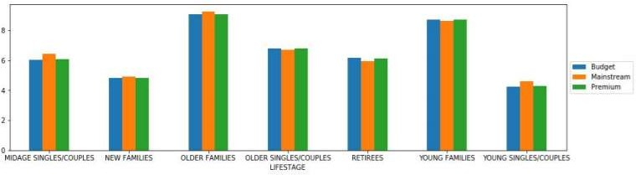

6

* + Sales mainly came from Budget - older families, Mainstream - young singles/couples, and Mainstream - retirees. In total, older customers buy more than younger customers. Non-premium customers buy more than premium customers.

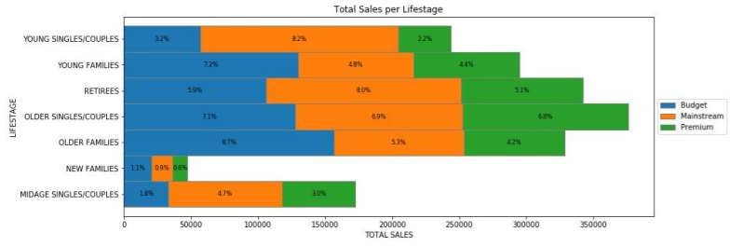

7

02

Trial store performance

8

* + We can see that Trial store 77 sales for Feb, March, and April exceeds 95% threshold of control store. Same goes to store 86 sales for all 3 trial months.
  + Whereas trial store 88 sales increase is insignificant.

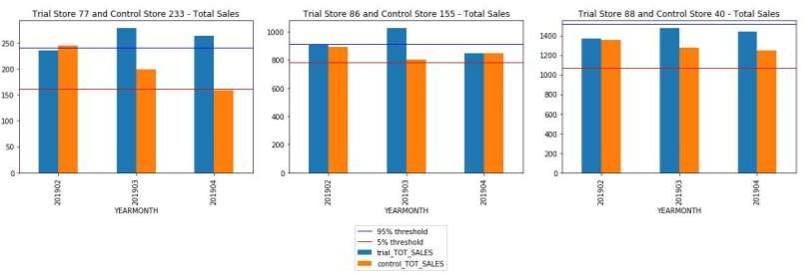

9

1. Trial store 77: Control store 233
2. Trial store 86: Control store 155
3. Trial store 88: Control store 40
4. Both trial store 77 and 86 showed significant increase in Total Sales and Number of Customers during trial period. But not for trial store 88. Perhaps the client knows if there's anything about trial 88 that differs it from the other two trial.
5. Overall the trial showed positive significant result.

10

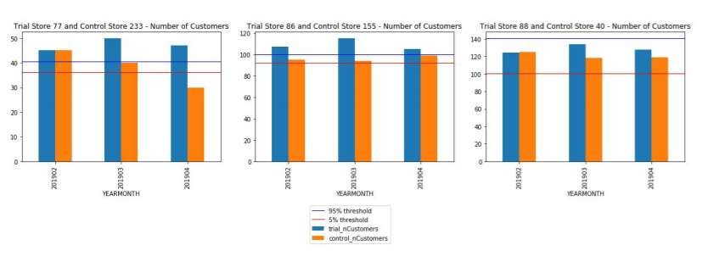

Disclaimer: This document comprises, and is the subject of intellectual property (including copyright) and confidentiality rights of one or multiple owners, including The Quantium Group Pty Limited and its affiliates (Quantium) and where applicable, its third-party data owners (Data Providers), together (IP Owners). The information contained in this document may have been prepared using raw data owned by the Data Providers. The Data Providers have not been involved in the analysis of the raw data, the preparation of, or the information contained in the document. The IP Owners do not make any representation (express or implied), nor give any guarantee or warranty in relation to the accuracy, completeness or appropriateness of the raw data, nor the analysis contained in this document. None of the IP Owners will have any liability for any use or disclosure by the recipient of any information contained in, or derived from this document. To the maximum extent permitted by law, the IP Owners expressly disclaim, take no responsibility for and have no liability for the preparation, contents, accuracy or completeness of this document, nor the analysis on which it is based. This document is provided in confidence, may only be used for the purpose provided, and may not be copied, reproduced, distributed, disclosed or made available to a third party in any way except strictly in accordance with the applicable written terms and conditions between you and Quantium, or otherwise with Quantium’s prior written permission

11